**Integrating Salesforce with Google Drive**

**Description:** Accessing documents stored in your Google Drive from Salesforce. Linking your Google Drive account with Salesforce and view and download data stored in your drive on Salesforce.

**Steps to Integration**

1. Salesforce Files Connect Setup
2. Salesforce Permission Set Setup
3. Salesforce Auth. Providers Setup
4. Google Cloud Platform Setup
5. Salesforce External Data Source Setup
6. Salesforce External Object Setup
7. Salesforce Google Drive Tab Setup

STEP 1:

Navigate to Setup>Feature Settings> Files Connect. And tick Enable Files Connect

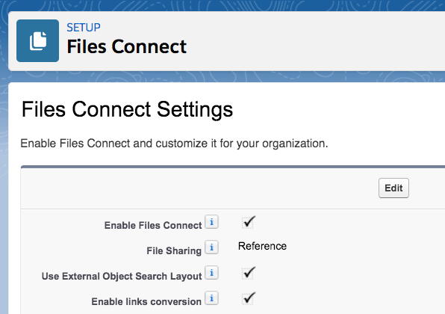

STEP 2:

Navigate to Setup> Users> Permission Sets. Create a new permission set. After creating new Permission set, edit its System Permissions and check its ‘File Connect Cloud’ checkbox and then save. Then assign this permission set to users.

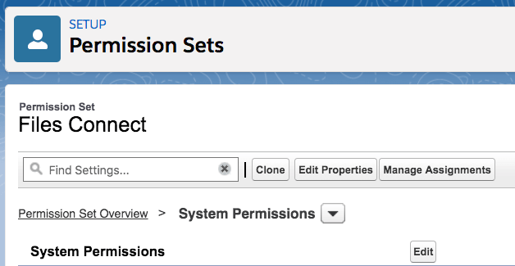

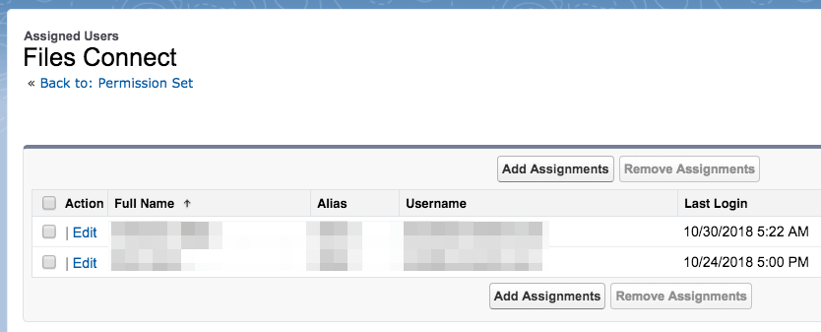

STEP 3:

In Setup, search on the word **auth.** Click on the **Auth. Providers** result.

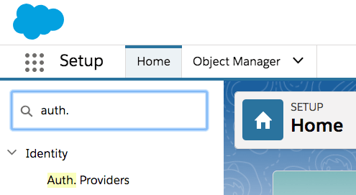

Create a new Auth. Provider.In the **Provider Type** field, select **Open ID Connect**. In the **Name** field, enter **Google Drive**. Add placeholder values to the four required files shown below. Click **Save**.

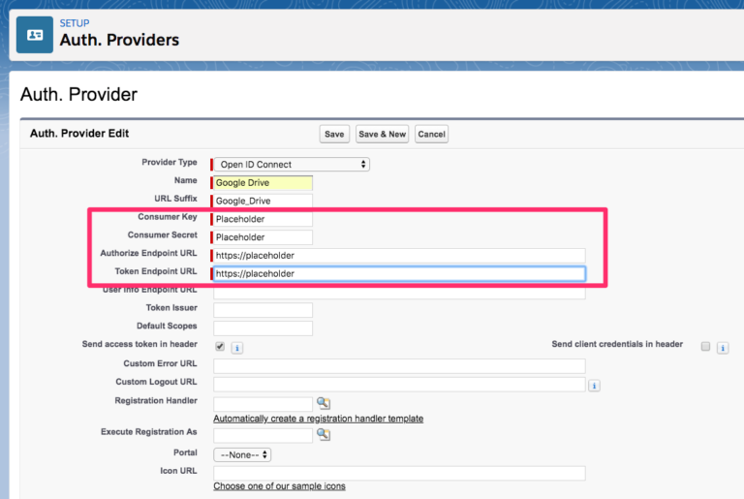

After saving, a **Callback URL** will be assigned in the Salesforce Configuration section.

STEP 4:

In [Google Cloud Platform](https://console.cloud.google.com/), click on **Select a project** (or an existing project name) and then click **New Project**.

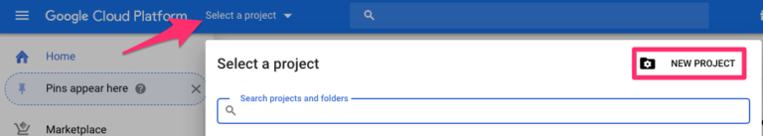

Name the project **Files Connect Google Drive**.

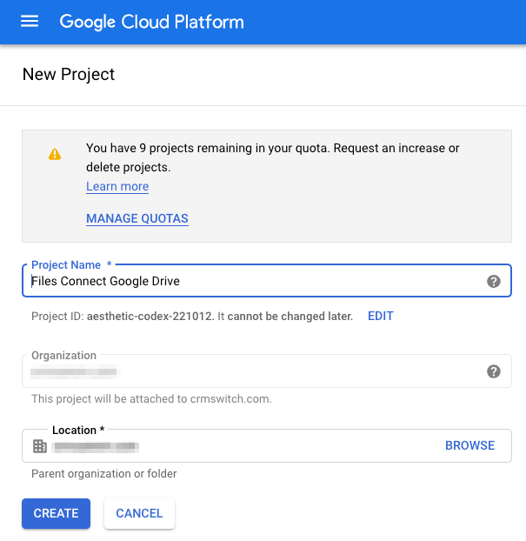

Search for and select the **Google Drive API**.

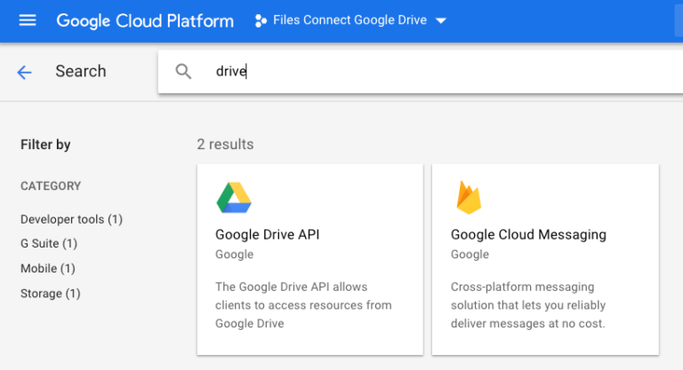

Click the **Enable** button to enable the **Google Drive API**.

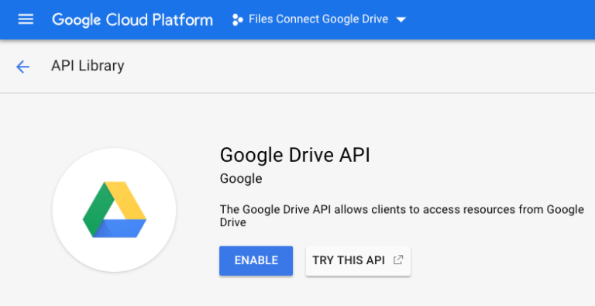

While still in the Files Connect Google Drive project, click the **Create Credentials** button.

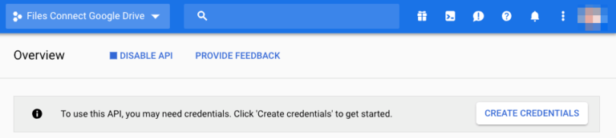

Select **OAuth client ID**.

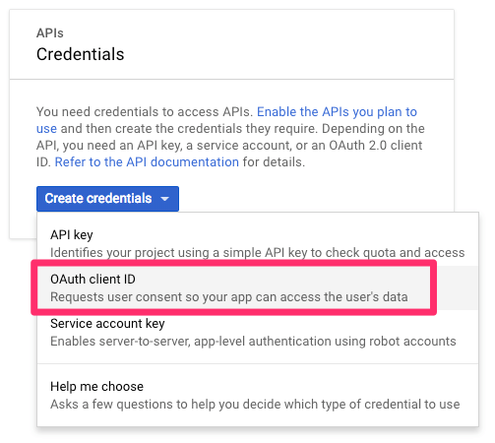

Click the **Configure consent screen** button.

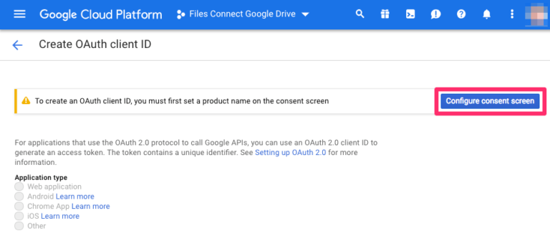

In the consent screen, under **Application Type**, select **Internal**. Give the application a name, such as **Files Connect for Google Drive**.

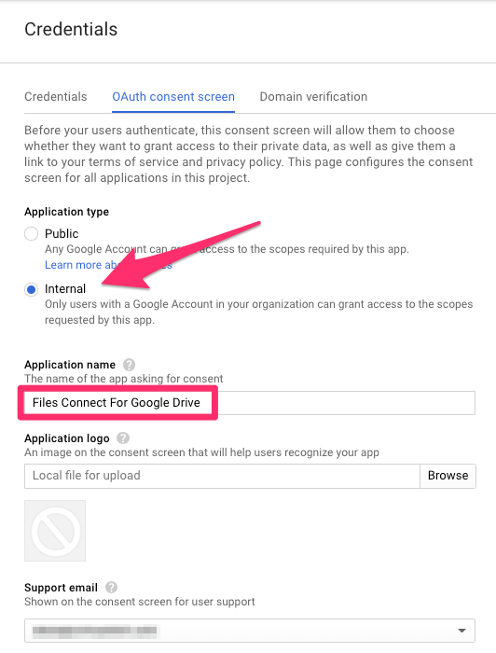

Under **Authorized domains**, add **salesforce.com**. Click **Save**.

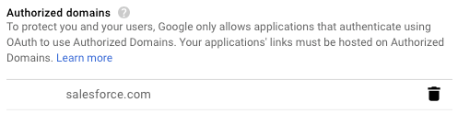

Select **Web Application**. In the **Name** field, enter **Salesforce**. Paste the callback URL from your text editor into the **Authorized redirect URIs** section. Click the **Create** button.

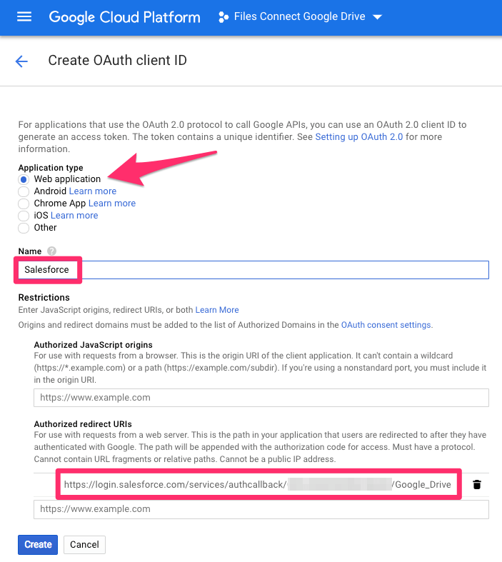

A **client ID** and **client secret** will be created.

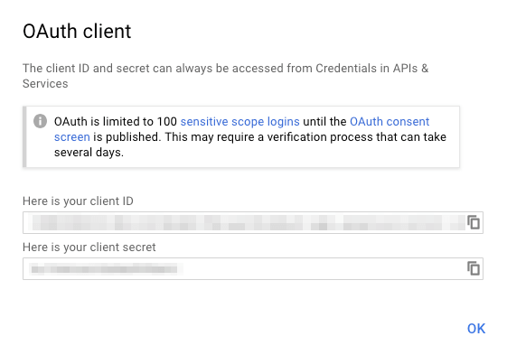

Copy the **client ID** and paste it into the **Consumer Key** field of the Auth. Provider Edit screen. Copy the **client secret** and paste it into the **Consumer Secret** field.

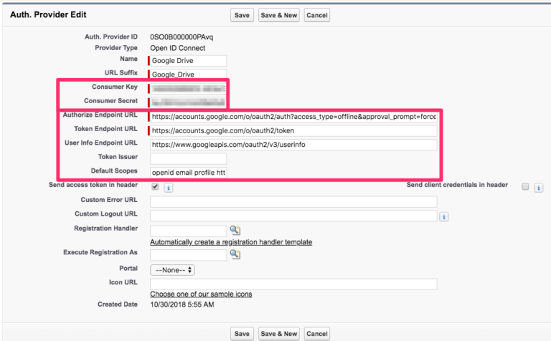

Copy and paste the following URLs into the corresponding fields in the Auth. Provider Edit screen (above).

**Authorize Endpoint URL:** https://accounts.google.com/o/oauth2/auth?access_type=offline&approval_prompt=force

**Token Endpoint URL:** https://accounts.google.com/o/oauth2/token

**User Info Endpoint URL:** https://www.googleapis.com/oauth2/v3/userinfo

**Default Scopes:** openid email profile https://www.googleapis.com/auth/drive

STEP 5:

Goto External Data Sources.and create a new External Data Source. And feed the following details.

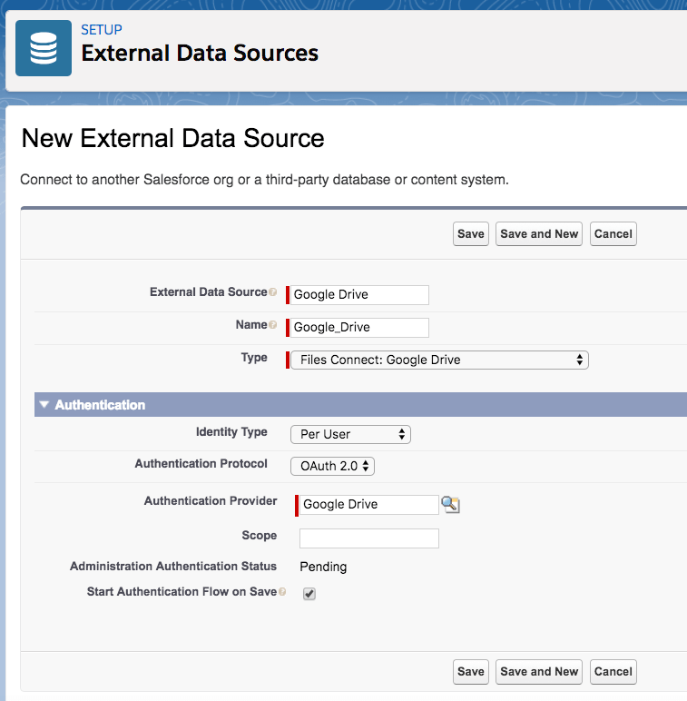

Then you will be taken to G Suit login page. Login.

Then go back to Files Connect permission set and add the External Data Source you created earlier to the right-hand Enabled External Data Sources column.

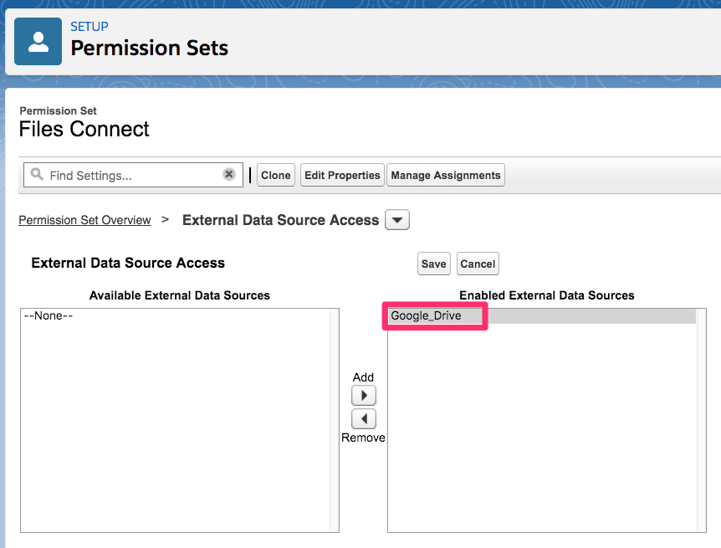

STEP 6:

In the External Data Source for google Drive, click on Validate and Sync.

An External Object will be created after this.

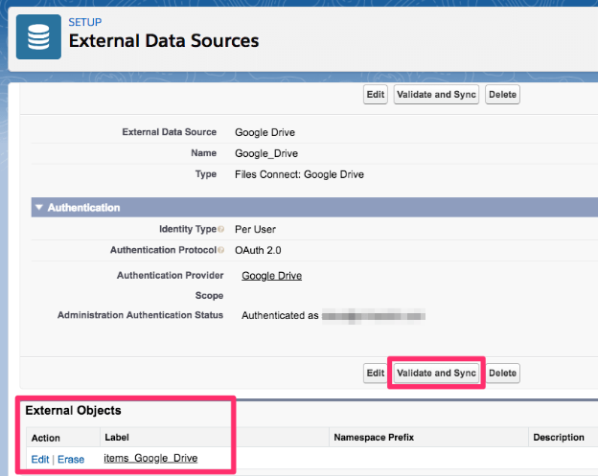

Now, click the Edit link under Action of External Object. And feed the following details.

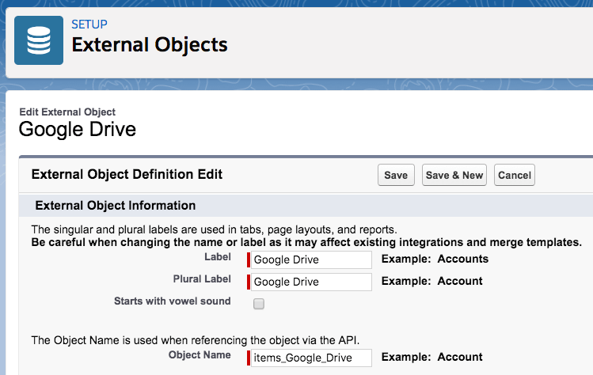

STEP 7:

Goto ‘Tabs’ in setup. And create a new Tab.

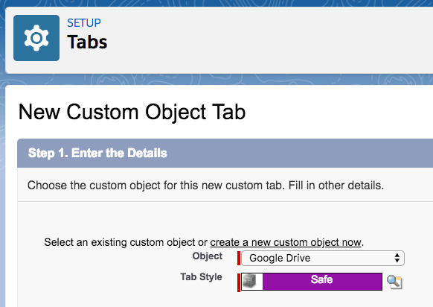

Complete the setup by assigning the tab to the appropriate Profiles.Users will now be able to add Google Drive files to Salesforce Files. They will also be able to create list views of Google Drive files in the Google Drive tab.Now to access Google Drive go to your your tabs,if you can’t find Google Drive check in “More” Tab and click on the Tab,here you will get a popup from salesforce requesting you to connect to your Google Drive account,after connecting successfully you will be able to see and download the files present in the Drive.

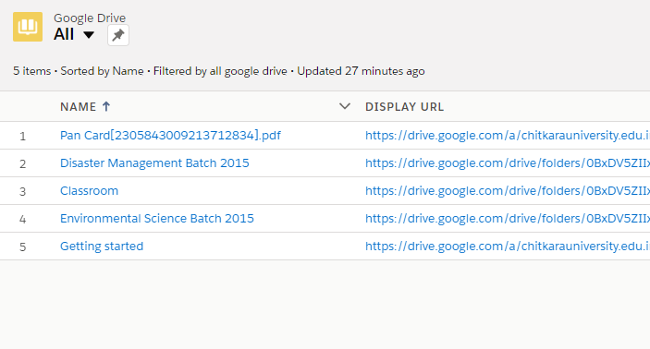Refernce:

https://www.lexnetcg.com/blog/gsuite/salesforce-files-connect-google-drive-setup/